**Project Charter**

**Project: Keep Trac**

**5/16/2023**

# PROJECT STATEMENT

We would like to create a calendar application that allows users to track what they need to do with specific days that are accurate to the calendar year, using a clean, organized UI.

# CONCISE PROJECT OVERVIEW

This project will take approximately 2 weeks. Although we do not have money to spend, we do need to budget our team, and we likely only have around 1 week of in-class time to work on it together. However, we can still work on it remotely collaboratively. We will need to get our project ideas approved. Key stakeholders include us as the developers and our clients. We are assuming specific needs from the client, but we will need to focus our ideas by consulting with them. Constraints include time and skills that may be beyond our current ability. A major risk we need to consider is the prospect of lost/corrupted files.

# SCOPE STATEMENT

When defining goals, we will be determining and listing our success criteria. One of the goals is that we are able to provide a login screen that allows for login credentials. For this specific project, we will have a specific login username and password (login key) to use for the client, however, we may consider connecting to a back-end integration in order to facilitate new accounts being made. This will allow us to add a layer of security and personalization to our client’s specific account. Another goal we have is that our product can display the calendar with selectable dates and with a clean, organized UI. Our third goal is to be able to display the specific date the client selects on the calendar to avoid any possible confusion and to improve clarity. The scope of this project does not currently include adding events or alarms, although these are expandable features that we will consider developing in the future.

# STAKEHOLDERS

-Satvik and Sunny: Developers who will be coding the product. We will need to communicate with each other on a regular basis both in-person and over remote communication to ensure that our project vision and development are on track and on the same page in order to satisfy the requirements for the final product.

- Client: We will need to consider the needs of the client and their desires. In the end, their satisfaction is the most important aspect of our considerations when considering stakeholders and how we shape our development around that.

# TIMELINE

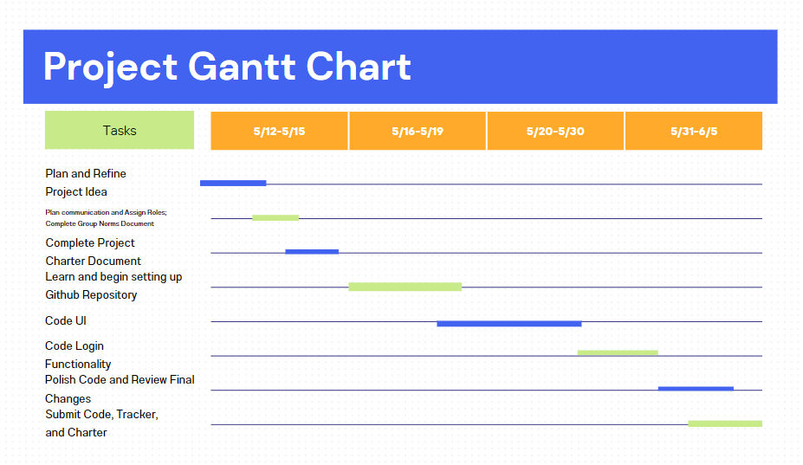

# BUDGET ESTIMATE(S)

We will only have around two to two-and-a-half weeks to complete this project. As such, it is important that we stick to the timeline that we created as diligently as possible in order for us to budget enough time to code the product and consult the necessary features we will include for the calendar application. Furthermore, we will need to recuperate any work that is not completed within the planned and allotted frame of time we have given ourselves by finding time outside of class to work on the project and ensure we are on the same page.

# RISKS AND CONTINGENCY PLANS

* Corrupted or lost files; mitigation plan: Practice source control using the GitHub repository with many versions in the backup. This way, we can track changes.
* Running out of time; mitigation plan: Stick close tot he timeline and allow for time to finish the project together and on time diligently.